|  |  |
| --- | --- |
| Garments inventory system |  |
|  |  |
| 2/11/2014 | Group-5 |
|  | Course no: CSE 308 course name: information system design  Submitted by: 1005047,51,53,56 &57 |

Garments inventory system

Group-5

Introduction:

Economy of Bangladesh is largely dependent on the garments sector. It has attracted worldwide attention in the sector of garments. Garments accounts for a nominal 76% of the country’s exports. International quality compliances are made at every stage. Here about 1.8 million workers are engaged. Bangladesh is placed 12 among the garments manufacturing countries in the world. But this sector still has a lot of untapped potential. Moreover, this sector is still using aged old traditional system for all its tasks. There are lots of scopes to automate many of its tasks which will not only increase their productivity but also will help them to take decisions in no times. So this sector really demands automated in its own rights.

Our System:

Our proposed system is “GARMENTS INVENTORY MANAGEMENT SYSTEM”. It is a fully automated system which will keep track of the products and stocks of a garments industry. At present, garment industries are using ancient paper-based methods to maintain their stock and accounts record. They keep their records in register books and even calculation is done manually sometimes. This process is error-prone, lengthy and cumbersome. By implementing our system we can save time, minimize losses and avoid mistakes.

Our subsystems:

Our system is divided into 5 subsystems in total. They are listed below:

1. Raw material storage
2. Raw material forwarding
3. Production stage tracking
4. Delivery of products
5. Machinery maintenance

1. Raw material storage:

This subsystem deals with the storage of raw material in the needed for production. Common raw materials needed for garments industry are cotton and unstitched clothes of various types and colors. This part of our inventory system automates the storage of these raw materials. The system automatically keeps track of the inventory balance. So when a demand comes it can be easily said whether there are enough raw materials.

Actors for this subsystem:

1. Main office
2. Storage manager
3. Storage worker
4. Production manager

Actors Glossary:

|  |  |  |
| --- | --- | --- |
| ACTOR | SHORT KEY | ACTIVITY SCOPE |
| Main office | MO | Places a demand for raw material, gives confirmation on receiving materials |
| Storage manager | SM | Checks and updates the storage balance |
| Storage worker | SW | Inputs the products in storage |
| Production manager | PM | Starts production on receiving materials |

Use case glossary:

|  |  |  |
| --- | --- | --- |
| Use case name | Description | Participant actors and roles |
| User demand | filling up a demand form depending on the nature of the contract | MO fills the form, SM receives it. |
| matching | After receiving the demands, the type and quantity of products is matched. | SM receives the order form, SW matches the requirements |
| Type matching | Type is matched | Same as matching |
| Quantity matching | Quantity is matched | Same as matching |
| Confirm order | After matching the order is confirmed | SM confirms the order, sends the goods to the factory, PM receives it, starts production, MO receives confirmation |
| Update storage | After sending an order, the balance of storage is updated | SW updates the balance, SM oversees it for transparency. |

Use case diagram: 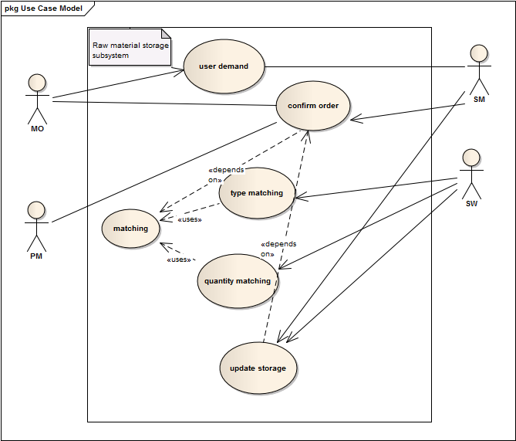

1.1: USER DEMAND

|  |  |
| --- | --- |
| Use case name: | User demand |
| Priority | High |
| Primary business actor | Main office(MO) |
| External receiver actor | Storage manager(SM) |
| Description | filling up a demand form depending on the nature of the contract |
| Trigger by | MO |

Table: Use Case Narrative for user demand

Typical course of events:

|  |  |
| --- | --- |
| Actor action | System response |
| Step 1: fill up a demand form and submit it online | Step 2: forward the form to the storage manager |
|  | Step 3: make an entry |

Documentation of the events of the user demand use case:

Conclusion: concludes when an entry of the demand is made.

Post condition: notify the main office of receiving their demand.

Implementation issues: a GUI will be provided for the MO to fill up the demand form online.

1. Delivery of products:

This subsystem deals with the delivery of products after completion of the production. The Delivery Manager informs the client that their goods are ready for delivery and sets the shipment date and process. After the products are sent for delivery, the Database Administrator updates the stock information but the delivery report option remains unchecked. When clients confirm that they have got all products alright, only then it is updated and the procedure is finished.

Actors for this subsystem:

1. Delivery manager
2. Database administrator
3. Client

Actors Glossary:

|  |  |  |
| --- | --- | --- |
| ACTOR | SHORT KEY | ACTIVITY SCOPE |
| Delivery manager | DM | Informs clients about delivery and ensures the total process of delivery |
| Database Administrator | DA | Updates the Stock information in database |
| Client | CL | Places order and receives good after production |

Use case glossary:

|  |  |  |
| --- | --- | --- |
| Use case name | Description | Participant actors and roles |
| Contact client | Contact is made to inform that products are ready for delivery | DM informs CL |
| Setting shipment procedure | Date, place and way of delivery is decided and clients are informed | DM sets date, place, way and informs client |
| Confirmation from client | Shipment procedure is finalized | Client confirms DM or demands any change |
| Database Updating | Stock information is updated | DA updates stock information |
| Confirm delivery | Ensuring that products have been received soundly | Clients confirm that they received products |
| Updating delivery report | After getting confirmation, the process is ended by updating delivery report as checked one. | DA updates delivery status |

Use case diagram:

4.1: Delivery of products

|  |  |
| --- | --- |
| Use case name: | Contact Client |
| Priority | High |
| Primary business actor | Delivery Manager(DM) |
| External receiver actor | Client |
| Description | Clients are informed that products are ready for delivery |
| Trigger by | DM |

Table: Use Case Narrative for contact client